* Compare recent advancements in edge-preserving image filtering techniques, such as bilateral filters, anisotropic diffusion filters, and newer methods like guided filters and non-local means filters.
* Discuss the implications of advancements in edge-preserving image filtering techniques for improving patient outcomes and the overall quality of medical diagnostics.

**Bilateral filter**

* It combines distance and range filters, assigning a weight depending not only on its spatial position relative to the central pixel but also on the similarity of its intensity compared to the value of the center pixel.
* Impact: on a homogeneous region with similar intensities, bilateral filer is a linear weight average and similar intensity pixels on the edges are smoothed.
* Gaussian functions with different standard deviations could be used for the domain which is proportional to the squared distance of pixel *(x,y)*, and another Gaussian represent the range filter and uses each coordinate.

**Advantages**

* Robust, recommended approach for most of the applications

**Disadvantages**

* Requires tuning of parameter σ.
* When a pixel has few similar pixels around it (often on an edge), the Gaussian weighted average is unstable.

**Guided Filter**

* For a given pixel, it found, in a guidance image G, the corresponding pixel and its corresponding spatial neighborhood:
* If the guidance image **G**, is the same as the input image to filter, the output image remains the same as the input image.
* Otherwise, the output image is, locally, a linear transformation of the guidance image G. The linear optimization aims in minimizing the error (least squares method) between the output image and the input image.

**Advantages**

* Parameter free, effective and efficient.

**Disadvantages**

* Can introduce blurry effects and artifacts.

Source: MATLAB

**Anisotropic Diffusion filter, Perona-Malik Filter**

* It uses the diffusion equation, a partial differential equation, which is nonlinear and space-variant, where intensities of the image are like the temperature which is modeled by the equation.

**Advantages**

* It favors smoothing within regions of smoother intensity and suppresses smoothing across the edges, while at same time reduces the noise.

**Disadvantages**

* The diffusion coefficient, (referred as K(x,t) in the course), can lead to instability: it can lead to backward diffusion that enhances contrast of image instead of smoothing it.
* Pictures: images show a significant noise decrease between before and after. Edges and sharpness are preserved.

**Non-local Means Filter**

It is weighted average of the neighborhood pixels; in its initial implementation the weights are defined using a Gaussian applied to the difference of intensities of local neighborhood of the center pixel. Therefore, the weighting function is determined by the similarity between neighborhoods. Other kernels like Turkey biweight, could be used to modify the weights more appropriately to include not only Euclidean difference in intensities but radiometric difference (color, depth distances, etc.…).

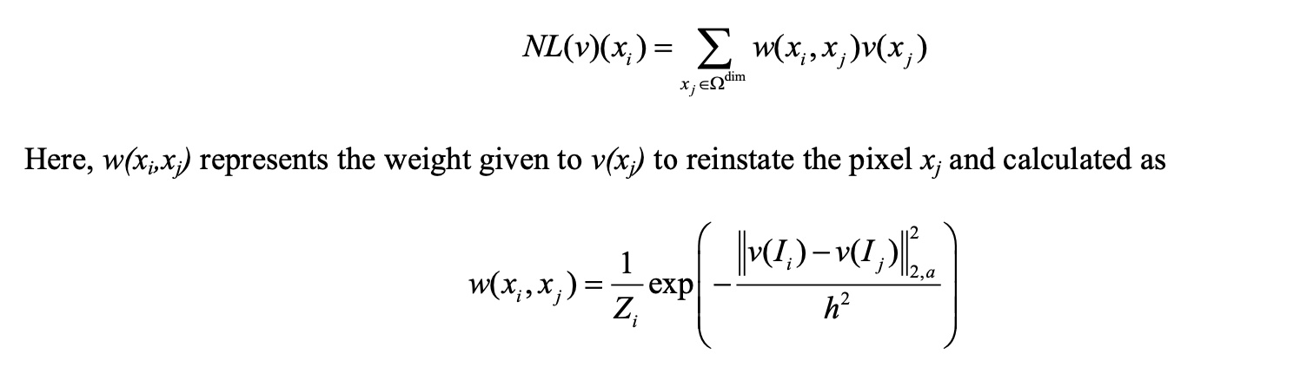

Non-local Means Filter with Gaussian Weights

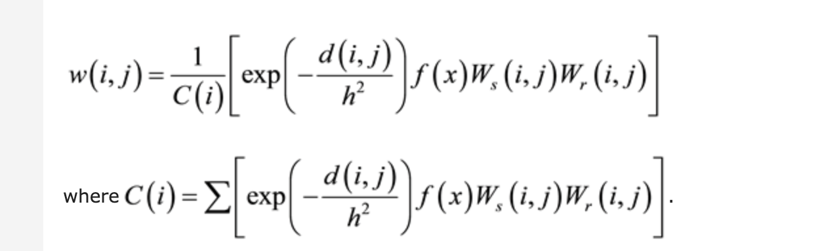

Other Example of Weights for Non-local Means Filter

**Advantages**

* It removes the noise from the images and yet preserves the sharpness of strong edges.
* It also smooths textures.

**Disadvantages**

Poor performances to denoise image with sharp edges [1].

Poor time resolution when applied to the medical diagnosis [2].

Computation cost [3]

Examples of Image Filtering

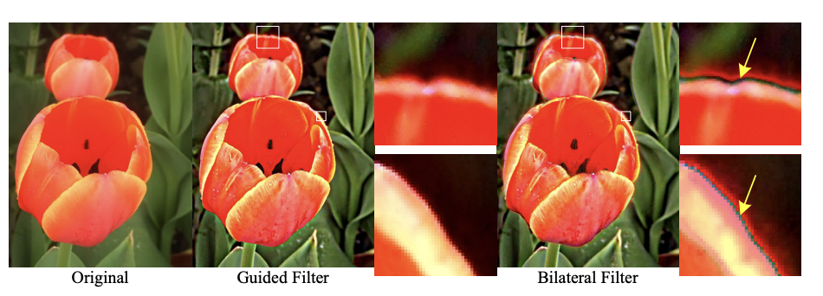

Bilateral Filter introduces an artifact within the edges (gradient reversal artifacts).

anisotropic diffusion filters

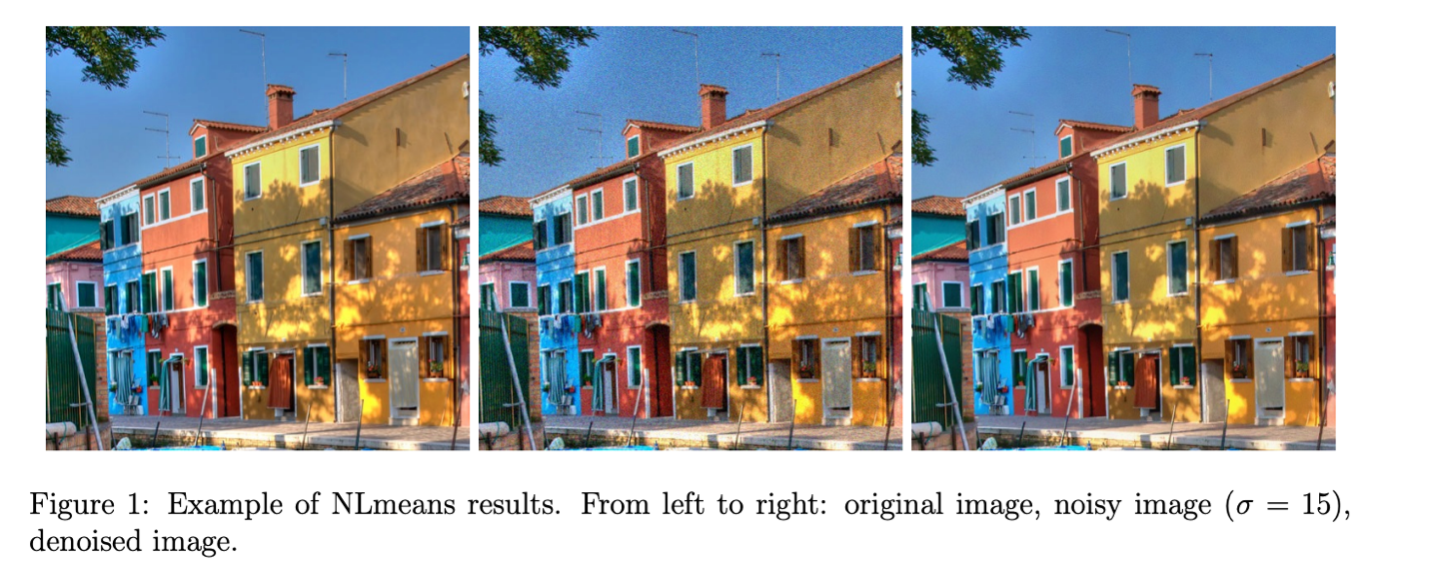

To reduce patient risk or discomfort, hospitals often employ low-dose or shorter imaging protocols for image acquisition, which comes at the cost of image quality. It has been reported that a decrease of radiation by 50%, increases noise level by 40%. In addition, deep learning models require large datasets which are not always easily available for privacy concerns, also these models could require significant storage, and GPU resources for training, and might be prone to overfitting.

Therefore, having better edge detection filtering algorithms, different than deep learning algorithms, which improves image quality becomes critical to maintain quality of medical prognoses, to enable early detection, monitor therapy progress and plan efficient treatment strategies: for ex., accurate prediction of pathological tumor response (shrinkage) enables hospitals to allocate donor livers more effectively [4].

Source

[1] Arian Maleki, Manjari Narayan, Richard G. Baraniuk, Anisotropic nonlocal means denoising,

Applied and Computational Harmonic Analysis, Volume 35, Issue 3, 2013, Pages 452-482, ISSN 1063-5203, https://doi.org/10.1016/j.acha.2012.11.003.

[2] Seungwan Lee, Youngjin Lee, The impact of improved non-local means denoising algorithm on photon-counting X-ray images using various Al additive filtrations, Nuclear Instruments and Methods in Physics Research Section A: Accelerators, Spectrometers, Detectors and Associated Equipment, Volume 1027, 2022, 166244, ISSN 0168-9002, <https://doi.org/10.1016/j.nima.2021.166244>.

[3] Coupe P, Yger P, Prima S, Hellier P, Kervrann C, Barillot C. An optimized blockwise nonlocal means denoising filter for 3-D magnetic resonance images. *IEEE Trans Med Imaging*. 2008;27(4):425-441. doi:10.1109/TMI.2007.906087

[4] Kong L, Huang M, Zhang L, Chan LWC. Enhancing Diagnostic Images to Improve the Performance of the Segment Anything Model in Medical Image Segmentation. *Bioengineering (Basel)*. 2024;11(3):270. Published 2024 Mar 9. doi:10.3390/bioengineering11030270